NATIONAL INFLUENZA VACCINE SUMMIT NEWSLETTER
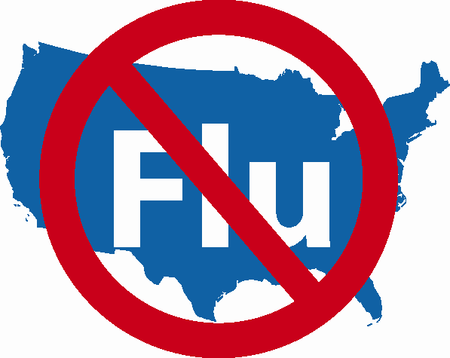

SPECIAL ISSUE!

Thank You!

Friday, December 1, 2006

Medical Professional Organizations
Please disseminate widely to all of your members.

NATIONAL INFLUENZA VACCINATION WEEK (NIVW)

November 27th – December 3rd

A “Thanks” to Those who Participated in Activities During NIVW and Beyond

Today, on December 1, 2006, it is with great admiration and thanks that we conclude the first annual National Influenza Vaccination Week.

With less than one month between the conception of a national effort to extend vaccination activities and the event itself, an amazing amount of energy, creativity, commitment, and hard work have been accomplished by countless individuals and organizations, including state and local public health officials, private healthcare providers across a wide variety of clinical settings, professional societies, community immunization providers, influenza vaccine manufacturers and distributors, and numerous federal agencies and departments. We have made an important first step in the important work of addressing the misconception that it is “okay” to stop vaccinating after Thanksgiving or that people vaccinated in November or December or beyond won’t benefit from vaccination.

We look forward to continuing this tradition next year with the second annual National Influenza Vaccination Week. With lessons learned from this year, it is our hope that next year’s effort will have an even greater impact and that we will be able to work even more closely with the same thoughtful and dedicated group of partners in planning and implementing next year’s activities.

