NATIONAL INFLUENZA VACCINE SUMMIT NEWSLETTER
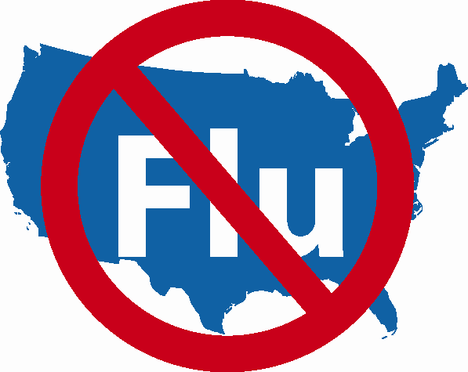

CORRECTION

(In bold red - 1st article)

Influenza Activity Spotlights

Thursday, November 30, 2006

Professional Medical Organizations
Please disseminate widely to all of your members.

NATIONAL INFLUENZA VACCINATION WEEK (NIVW)

November 27th – December 3rd

Influenza Activities and Partnerships

during NIVW and Beyond

Collaboration between health departments and traditional/non-traditional partners to increase influenza vaccine coverage can benefit communities both during NIVW and beyond. Below are four examples of partnership activities.

Chicago Department of Public Health
A Creative Partnership with Local Legislators

The Chicago Department of Public Health (CDPH) purchases 50,000 doses of influenza vaccine each year which are administered in a number of venues. Among their many partners, CDPH has found local legislative representatives, or aldermen, to be very supportive with successful outcomes. This is because offices are conveniently located and have the ability to promote the vaccination clinics to their elderly constituents. In 2006, CDPH distributed over 8,000 doses of influenza vaccine to the 39 participating Aldermanic offices. A clinic is scheduled during NIVW.

With the clinic partnerships and strong support from the city’s Aldermen, CDPH has been able to secure consistent annual city funding for the purchase of influenza vaccine.
For additional information, please contact Julie Morita, M.D., Medical Director of the Immunization Program, at (312) 746-6088.

Washoe County District Health Department (Nevada)
“Cocooning” Program

The Washoe County District Health Department in Reno, Nevada has partnered with the Nevada State Health Division and Renown Regional Medical Center to provide an extra bit of protection for vulnerable infants before they leave the hospital by offering a “cocooning” program – one of the first programs of its kind in the nation.

The concept of “cocooning” is simple. A newborn baby has little if any immunity to influenza for the first 12 months of life. To ensure protection for the baby, immediate household contacts (representing its cocoon) are vaccinated against influenza so they won’t transmit the virus to the baby. The program began in July 2006 with pertussis vaccination and it now includes seasonal influenza vaccinations as well.

The State Health Division supplies the vaccine. Renown Regional Medical Center administers vaccinations to new parents. The Washoe County District Health Department provides training, support and access to its immunization registry to Renown’s staff. This effort is a great example of the positive impact partnerships of this kind can have for the communities served. This program will continue during and following NIVW until vaccine supplies are exhausted. For additional information, please contact Judy Davis, Public Information Officer, at (775) 843-3946.

California Boomer Biker Immunization Ride to Support December and January Vaccination

With a record number of up to 110-115 million doses of influenza vaccine projected for the 2006-2007 season, various means for encouraging a greater percentage of the population to receive the vaccine were sought. San Diego County's Immunization Branch was asked to put together an event to promote immunization against influenza for healthy adults, particularly individuals over age 50. The event would be videotaped for use as a Video News Release (VNR) and distributed to media outlets throughout the state.

To call attention to our message, a collaboration of State and local Immunization Programs, the California Adult Immunization Coalition, and the California Distance Learning Health Network put together an event in partnership with Biggs Harley-Davidson, a local motorcycle dealership, and its affiliated Harley Owners Group. The “Boomer Biker Immunization Ride” video news release (VNR) was developed using motorcycle riders as a visual for the message that all adults, particularly those over 50, should be protected against the flu. A local motorcycle dealership and riding club agreed to participate. The group was videotaped riding through the countryside, then returning to the agency and receiving flu shots. Some of the bikers provided comment and demonstrated preventive measures. Medical experts were on hand to answer questions and provide sound bites. This VNR will be promoted during and following NIVW.

Colorado Department of Public Health
and Statewide Immunization Coalition Launch NIVW

The timing of the National Influenza Vaccination Week (NIVW) coincided with Colorado Influenza and Pneumococcal Alert Coalition’s (CIPAC’s) 2006-2007 plans for distribution of November messages regarding influenza vaccination. Following the announcement of NIVW, CIPAC not only continued planned activities, but also was further motivated to push forward with additional enthusiasm and renewed efforts. On CIPAC’s influenza clinic locator, there are over 200 posted clinics scheduled statewide during National Influenza Vaccination week

Starting on Monday, November 27, the Park Meadows mall in Denver will be handing out a CIPAC card entitled “Beat the Bug”. These cards (1) offer methods to prevent influenza transmission; (2) advertise CIPAC’s influenza clinic locator (www.immunizecolorado.com); and (3) provide the Colorado Health Line’s toll free number (1-877-462-2911). CIPAC also will distribute a press release recognizing NIVW and purchase sponsorship on Colorado Public Radio, which has statewide coverage. The message will be to remind healthcare workers “it is not too late to vaccinate, with more information available at immunizecolorado.com”. The Colorado Immunization Program also hosted a statewide conference call for Colorado healthcare providers on Monday November 27, during which these providers were encouraged to continue vaccinating through December. For additional information, please contact Roberta Smith at (303) 692-2332.

