NATIONAL INFLUENZA VACCINE SUMMIT NEWSLETTER
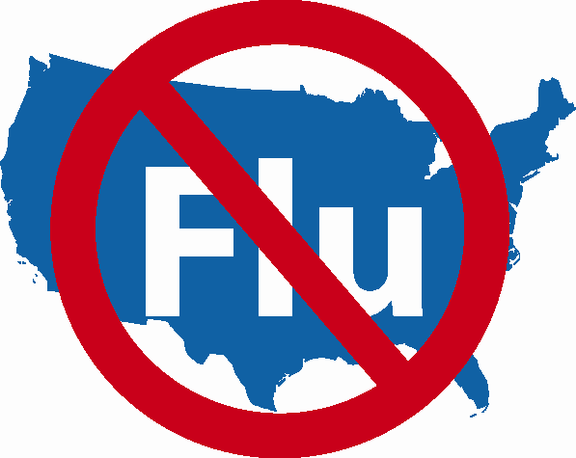

SPECIAL ISSUE!

Resources for NIVW & Beyond

Wednesday, November 29, 2006

Medical Professional Organizations
Please disseminate widely to all of your members.

NATIONAL INFLUENZA VACCINATION WEEK (NIVW)

November 27th – December 3rd

Easy Access to Resources for use During NIVW,

December, and Early 2007

National Influenza Vaccination Week (NIVW)
http://www.cdc.gov/flu/nivw06.htm
http://www.preventinfluenza.org

Flu Clinic Locator from American Lung Association
1. Where can I get a flu shot? (for the general public)
www.flucliniclocator.org
Enter your zip code and find clinic dates and locations in your area.
2. Where can I advertise my public clinics? (for healthcare providers)
www.lungusa2.org/embargo/flucliniclocator/FCLAgreement0806.doc.
To enroll, print form, fill out, sign, date, and fax to (212) 315-8870.

Influenza Vaccine Availability Tracking System (IVATS)
1. How can I let healthcare providers know I have flu vaccine for sale?
(For vaccine manufacturers and wholesale distributors)
http://www.ama-assn.org/ama/pub/category/16919.html
Click on "How do I enroll".
2. Where can I purchase influenza vaccine?
(For healthcare providers and vaccinators)
http://www.ama-assn.org/ama/pub/category/16919.html
Click on "influenza vaccine for sale".

National Influenza Vaccine Summit – NIVW
http://www.ama-assn.org/ama/pub/category/13732.html

Patient and Provider Education Materials
http://www.cdc.gov/flu/professionals/patiented.htm

