NATIONAL INFLUENZA VACCINE SUMMIT NEWSLETTER
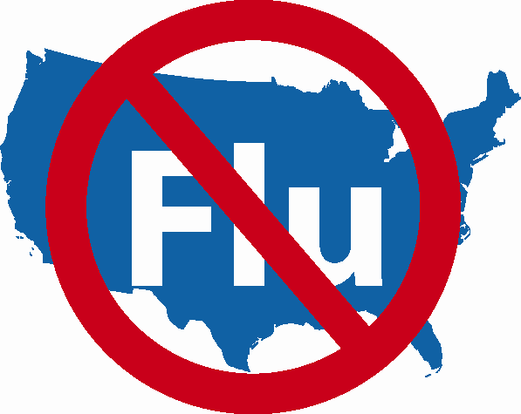

SPECIAL ISSUE!

Vaccine Supply Issues?

Tuesday, November 28, 2006

Medical Professional Organizations
Please disseminate widely to all of your members.

NATIONAL INFLUENZA VACCINATION WEEK (NIVW)

November 27th – December 3rd

What Can Healthcare Providers Do if They Have Little or No Vaccine During NIVW?

While CDC anticipates an unprecedented number of influenza vaccine doses this season and understand from the manufacturers that the vast majority of doses will be distributed by the end of November, we recognize that many providers didn’t receive their vaccine as early in the vaccination season as they would have liked, making it difficult for them to vaccinate all of their patients during October and early November. In addition, some providers may still be awaiting completion of their vaccine orders as NIVW begins. This brief document is intended to provide guidance and suggestions for providers in that situation.

The purpose of NIVW is to emphasize the importance of influenza vaccination and the need to continue vaccination activities beyond Thanksgiving and into December and January, with providers implementing outreach and offering vaccination prior to, during, and following NIVW that are tailored to the patients they plan to serve and the vaccine supply that they have available.

For providers who are concerned that they will not have sufficient vaccine available during NIVW, we recommend using this week to do outreach to patients, letting them know that vaccination opportunities will continue into December and beyond, what those opportunities are, and if needed, to schedule appointments for those opportunities. Providers can also contact their local or state health department to learn about other health care providers and clinics in their communities that are administering influenza vaccine.

If patients reach out to a provider for vaccination and vaccine is not yet available, the importance of this outreach can be positively reinforced with the patient, and information can be shared about the opportunities that the provider is planning for vaccination in the coming weeks. If appointments will be needed for these opportunities, an appointment can also be scheduled.

For patients who express concern about the fact that a vaccination isn’t immediately available at the time they contact the provider, the following information and talking points are suggested:
- I appreciate your interest in calling about an influenza vaccination for yourself or your family member.
- Ideally, people should be vaccinated by the end of November, but it is certainly not too late to get the vaccine in December or January in most years. The flu season typically peaks in February or later, so CDC recommends continuing to vaccinate into December, January, and beyond as needed.
- This is why CDC and other groups are sponsoring National Influenza Vaccination Week during the last week of November, to get out the message that continuing to vaccinate beyond Thanksgiving is important to protect Americans against the flu.
- At this time, I am planning to administer the vaccine ________________(timing and types of vaccination opportunities that are planned)________.

For providers who have already used their doses and aren’t scheduled to receive further shipments, additional vaccine is still available for purchase. Distributors with vaccine for sale have been invited to post vaccine availability at this AMA-sponsored website: http://www.ama-assn.org/ama/pub/category/16919.html. For more information about NIVW, go to the CDC website at: www.cdc.gov/flu .

