NATIONAL INFLUENZA VACCINE SUMMIT NEWSLETTER
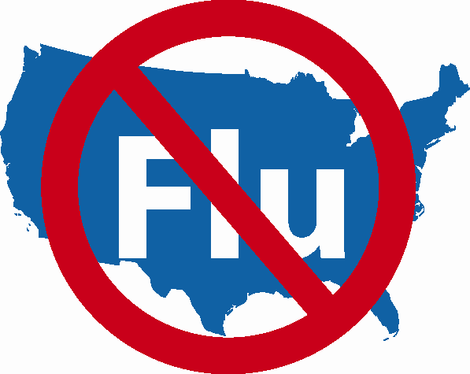

SPECIAL ISSUE!

A Letter from Dr. Gerberding

Monday, November 27, 2006

NATIONAL INFLUENZA VACCINE WEEK (NIVW)

November 27th – December 3rd

Dr. Gerberding Announces NIVW

Department of Health & Human Services
_______________________________________________________________________

Centers for Disease Control
and Prevention (CDC)
Atlanta, GA 30333

November 21, 2006

Dear Colleague:

The United States Department of Health and Human Services (HHS), the Centers for Disease Control and Prevention (CDC), the National Influenza Vaccine Summit, partners, and stakeholders have announced a National Influenza Vaccination Week (NIVW) that will occur from Monday, November 27th through Sunday, December 3rd, 2006. This event is designed to raise awareness of the importance of continuing influenza vaccination, as well as to foster greater use of influenza vaccine through the months of November, December, and beyond. CDC is recommending that all people wishing to avoid influenza take this opportunity to be vaccinated. We are hopeful that you, influenza vaccine providers, will use this time to (1) enhance influenza vaccine availability by scheduling additional clinics and extending clinic hours when feasible and (2) let patients know about your plans for vaccination opportunities during the coming weeks.

This year, we expect record amounts of influenza vaccine (up to 110-115 million doses) to be available by the end of December. We are also aware that the phased nature of vaccine distribution has resulted in many providers not receiving their full orders of vaccine as early in the vaccination season as they would have liked, making it difficult for them to vaccinate all of their patients during October and early November. To address this challenge, and to protect as many Americans as possible against this serious disease, we want to urge providers to vaccinate every individual who wants to be protected against influenza – during NIVW, into December, and beyond.

As long as you have vaccine available, we hope you will offer it to every patient who enters your clinic or office. Even patients who do not typically seek vaccination are often motivated to do so when their provider recommends it. Unused vaccine is something we all want to avoid, knowing that it does nothing to help protect the 300 million Americans, and particularly, approximately 218 million Americans recommended for vaccination every year because they are at high risk of suffering influenza-related complications, or because they live with or care for someone at high risk. This year’s ample vaccine supply ensures that anyone else who wishes to be protected against influenza should be vaccinated.

For providers who are concerned that they will not have sufficient vaccine available during NIVW, we recommend using this week to let patients know that vaccination opportunities will continue into December and beyond, and if needed, to schedule appointments for those opportunities. If you are certain that you will not be able to offer influenza vaccine during or after NIVW, you may wish to check with your local or state health department, or go to www.cdc.gov/flu/protect/keyfacts.htm so that you can find and recommend other local clinics that will offer the vaccine.

We want to alert all providers that the National Influenza Vaccine Summit has developed the Influenza Vaccine Availability Tracking System, or IVATS. This system helps link providers with vaccine by giving them access to information about which distributors have influenza vaccine for sale, and how to contact and order vaccine from these distributors. IVATS is available online on the Internet at www.ama-assn.org/ama/pub/category/16919.html.

Finally, please do not forget to get vaccinated yourself for your own benefit, and to protect your patients, co-workers, and loved ones from influenza

For more information on NIVW, please visit the CDC website at www.cdc.gov/flu and click on the NIVW box.

Julie Louise Gerberding, M.D., M.P.H.
Director

