NATIONAL INFLUENZA VACCINE SUMMIT NEWSLETTER
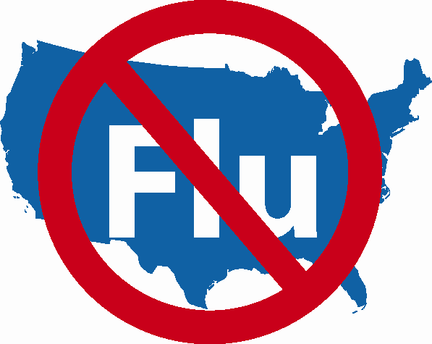

SPECIAL ISSUE!

Friday, November 17, 2006

ATTENTION!

ALL HEALTHCARE PROVIDERS AND VACCINATORS

NATIONAL INFLUENZA VACCINE WEEK (NIVW)

November 27th – December 3rd

How to Promote Your Influenza Clinics

from November through January

To support the intent of the National Influenza Vaccine Week (NIVW), the American Lung Association (ALA) and Maxim Health Systems continue to offer their national Flu Clinic Locator to assist the public in identifying local influenza vaccination clinics that are open to the public.

The primary reason the ALA Flu Clinic Locator was established was so persons in your community seeking an influenza vaccination would be able to find clinics in their areas. To do so, they may go to www.flucliniclocator.org.and enter their zip code. A list of dates, times and locations of clinics in their areas will “pop up”.

As we prepare for NIVW, it will be helpful to the public for this site to be as broadly populated as possible. We encourage all providers and vaccinators who will be holding public vaccination clinics during NIVW and the weeks that follow, to post their clinics on this site.
If you would like to enroll your clinic(s), go to: www.lungusa2.org/embargo/flucliniclocator/FCLAgreement0806.doc.

Print and complete the Flu Locator Agreement Form
and fax to: (212) 315-8870.

We also realize there are other flu clinic locator systems throughout the country. To increase public awareness of and access to public influenza clinics, please consider enrolling and also posting your clinics on ALA’s locator.

Thanks for supporting our efforts to increase influenza vaccine coverage both during NIVW and throughout November, December and January.

